Free 7 day Master Class

AWS PROJECT

FACE DETECTION APP USING AWS

NAME: Kolla Gnanaprasuna

Register Number: 16MIS0142

College : VIT, Vellore.

SCREENSHOTS:

1. AWS LOGIN SCREEN WITH USERNAME

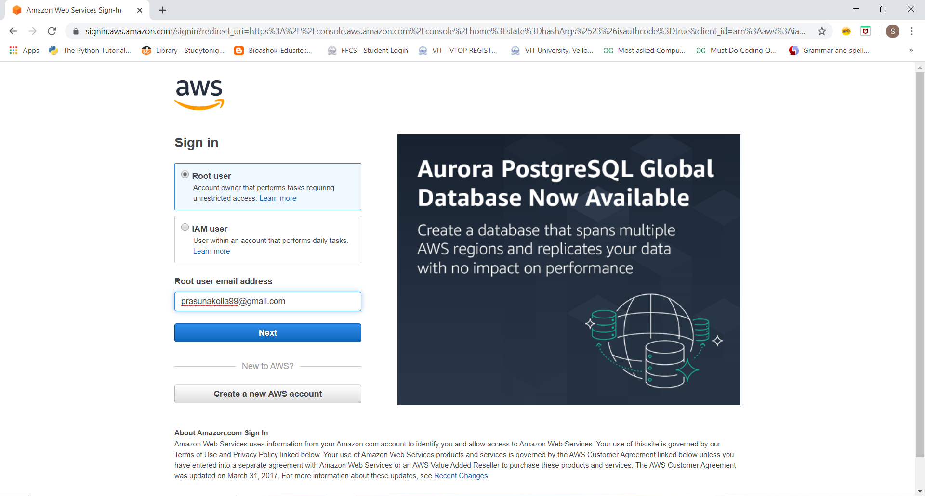

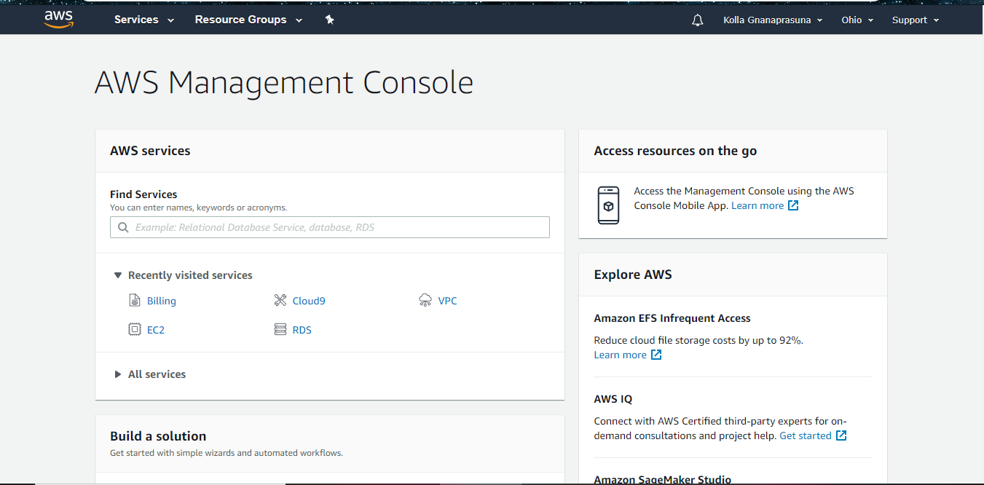

1. EC2 DASH BOARD

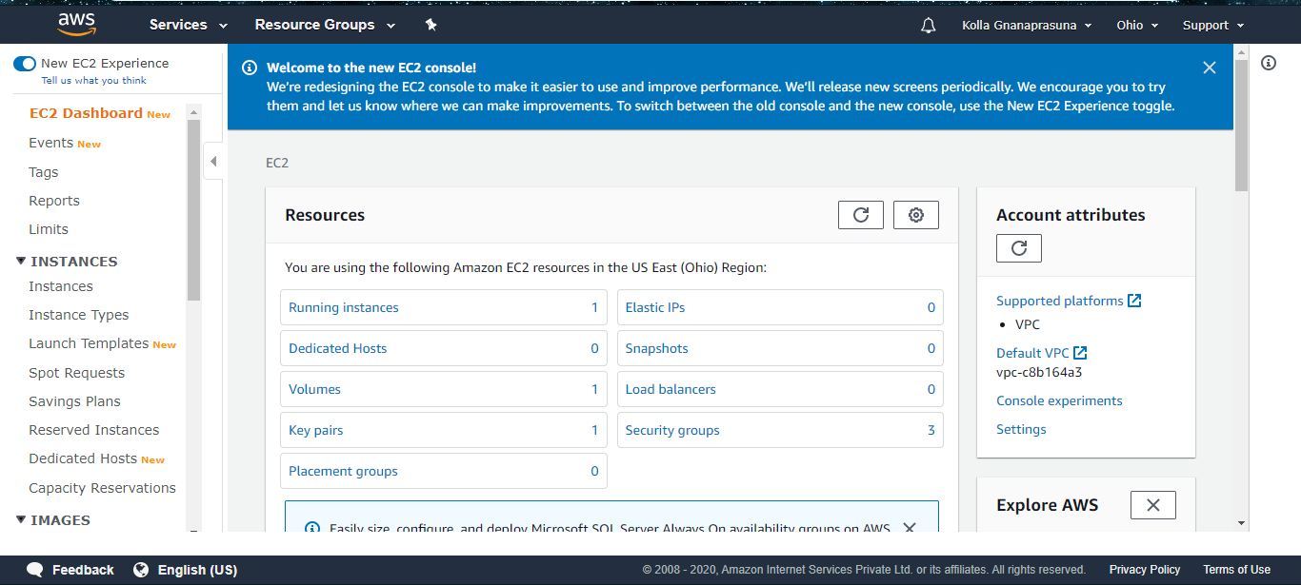

3.S3 DASHBOARD

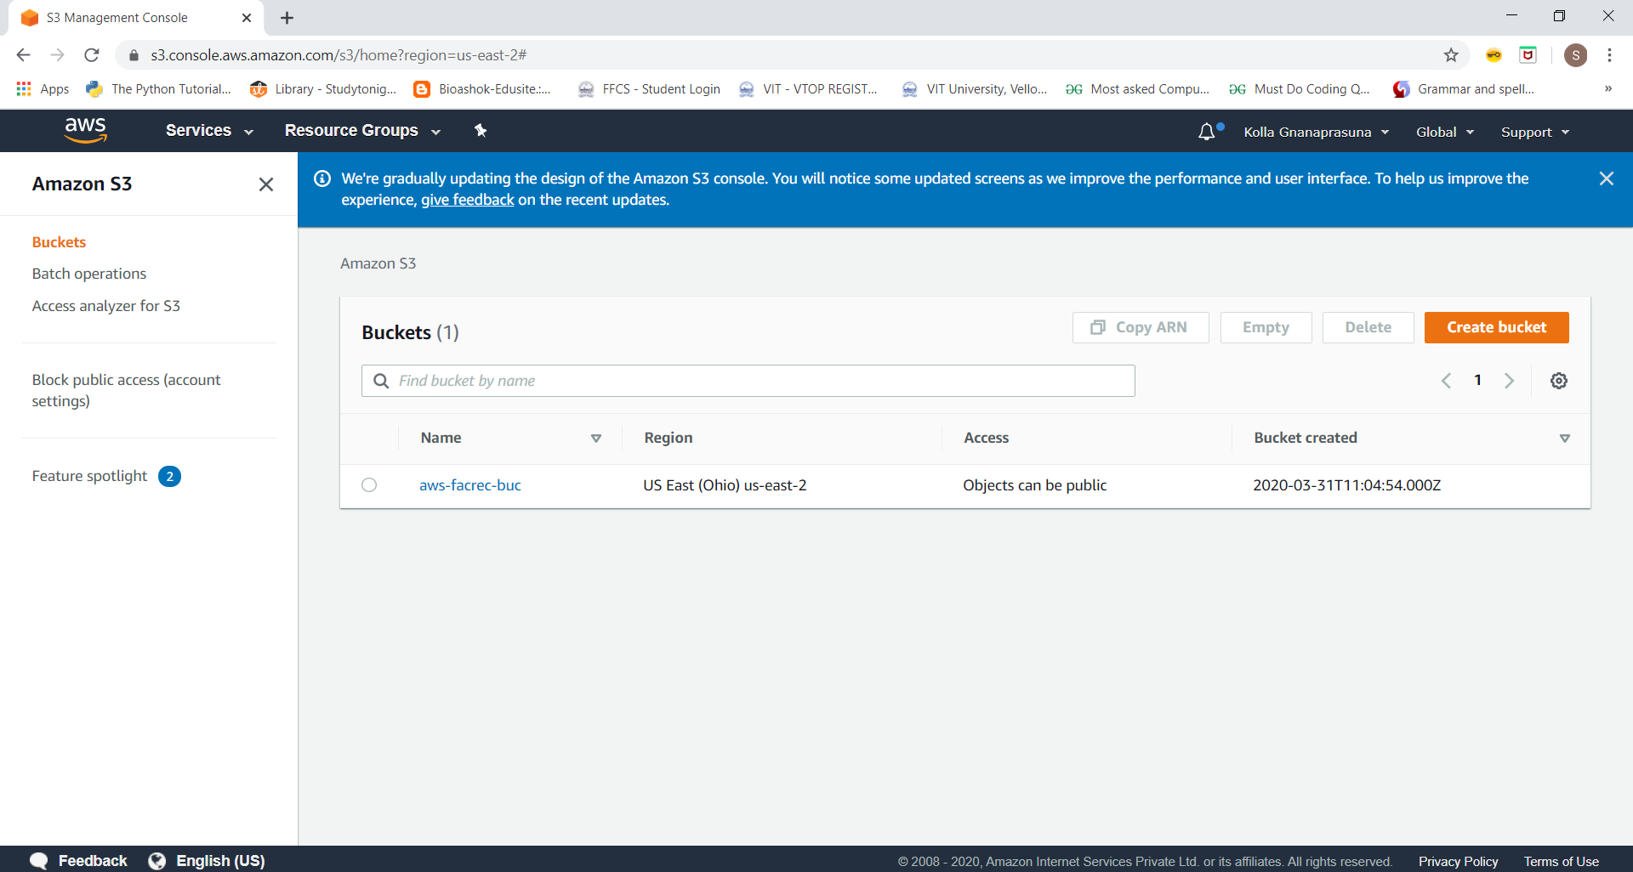

4.REKOGNITION DASHBOARD

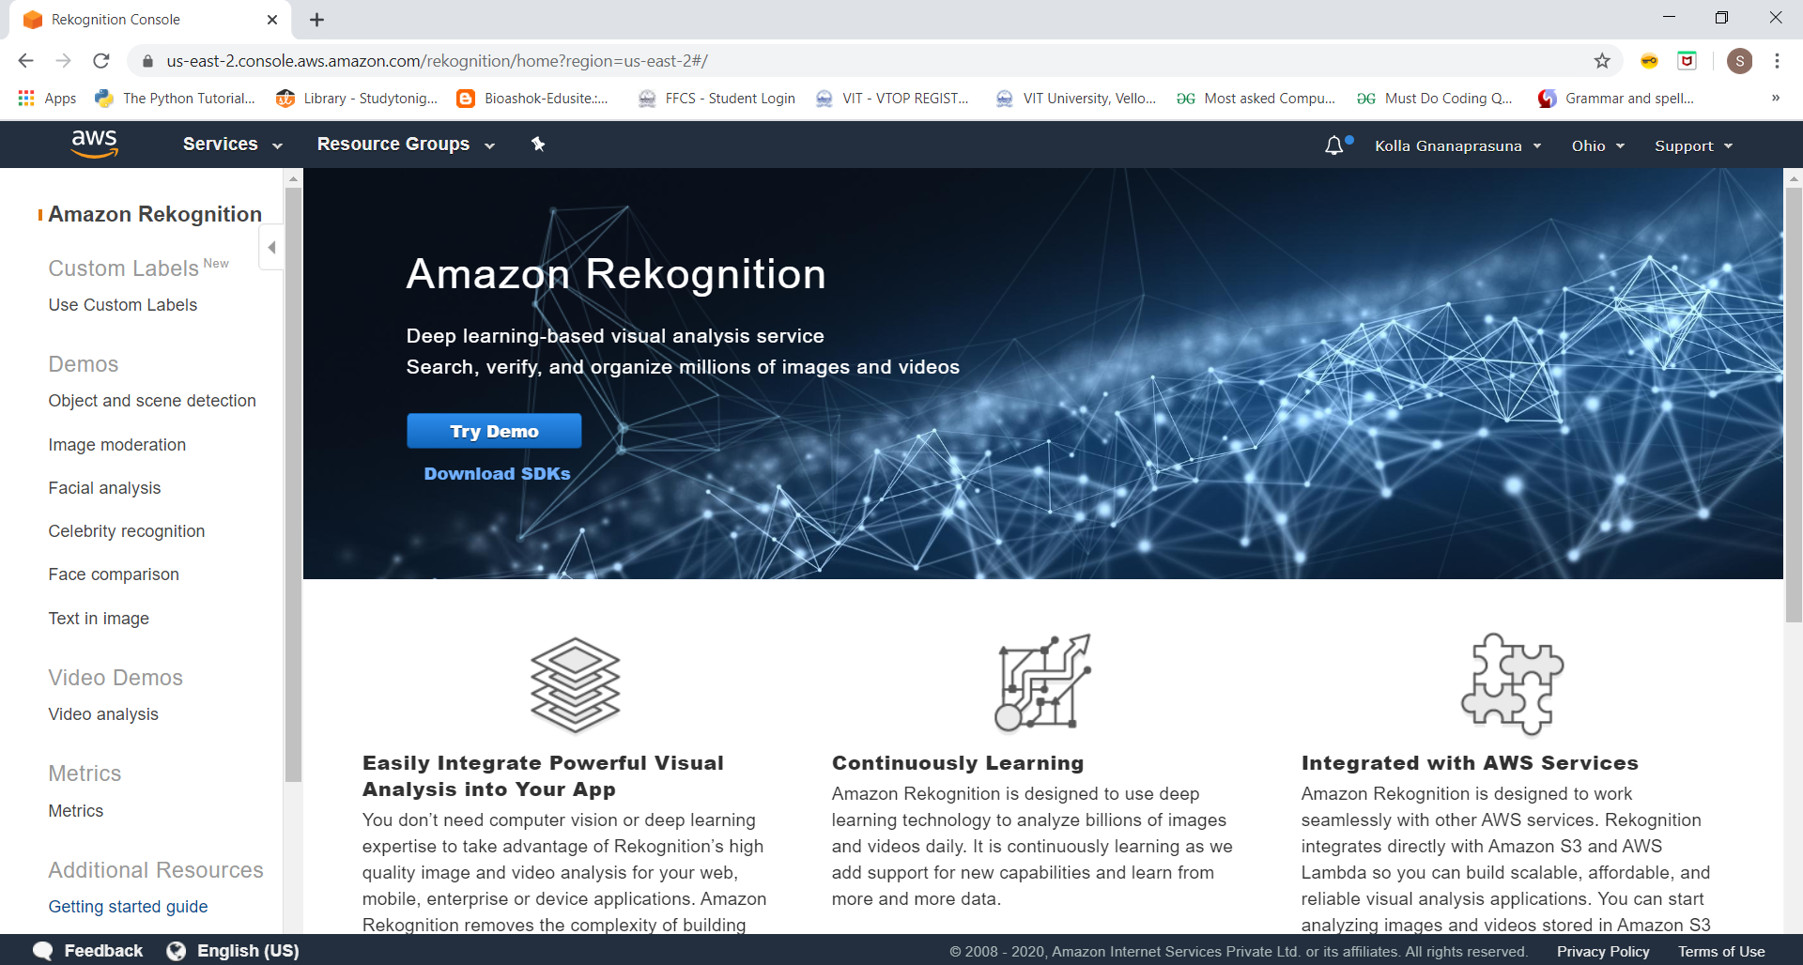

SCREENSHOTS FOR EC2

1. CHOOSING AN AMI

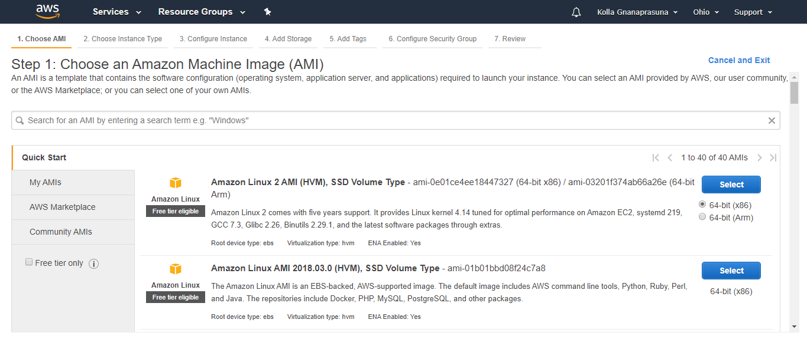

1. CHOOSING AN INSTANCE TYPE

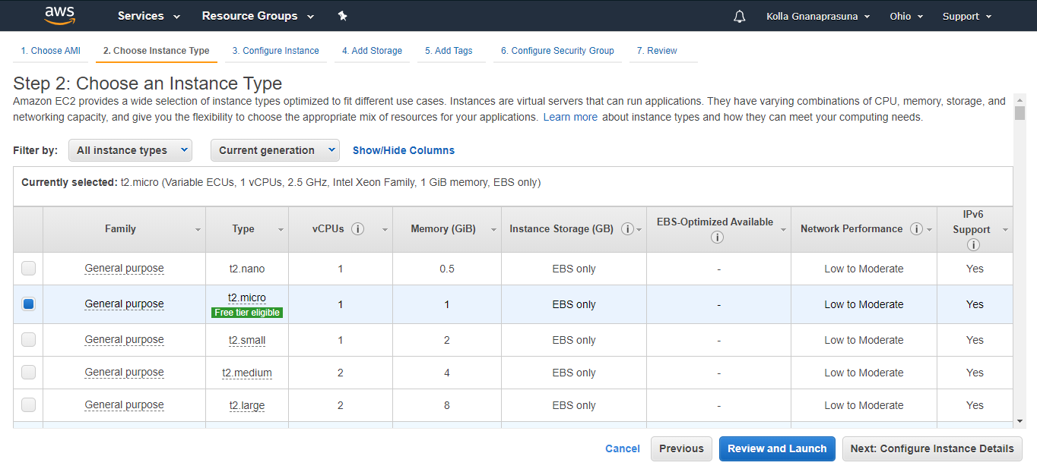

1. ADDING STORAGE

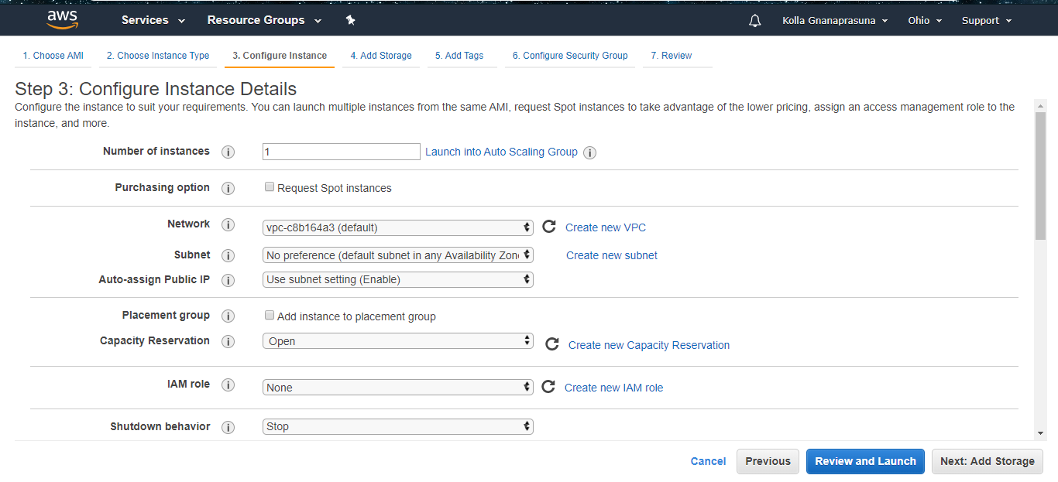

1. CONFIGURING SECURITY GROUP

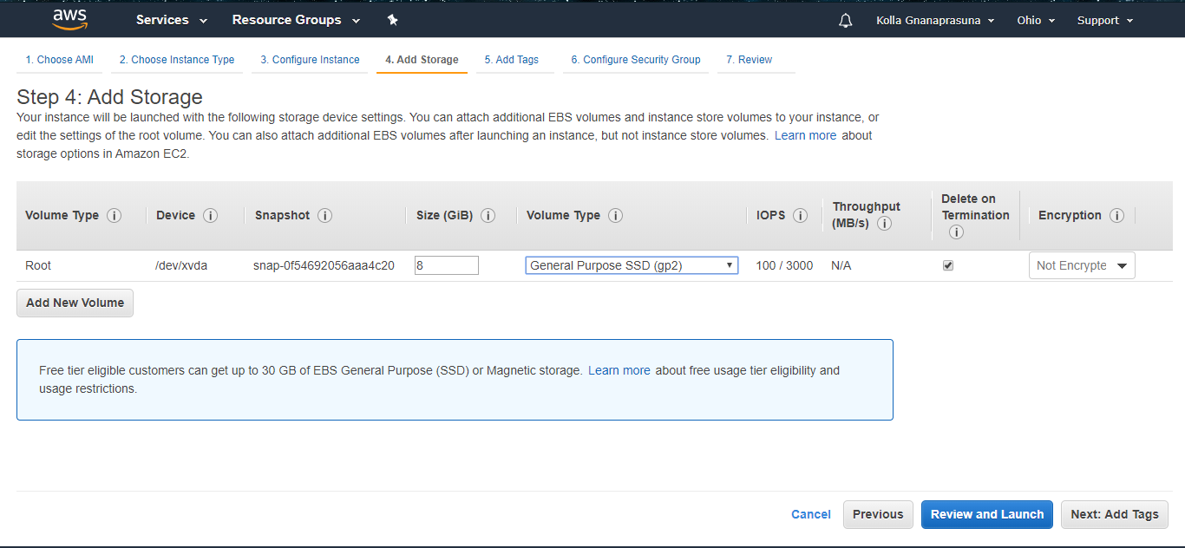

1. KEY PAIR DOWNLOAD

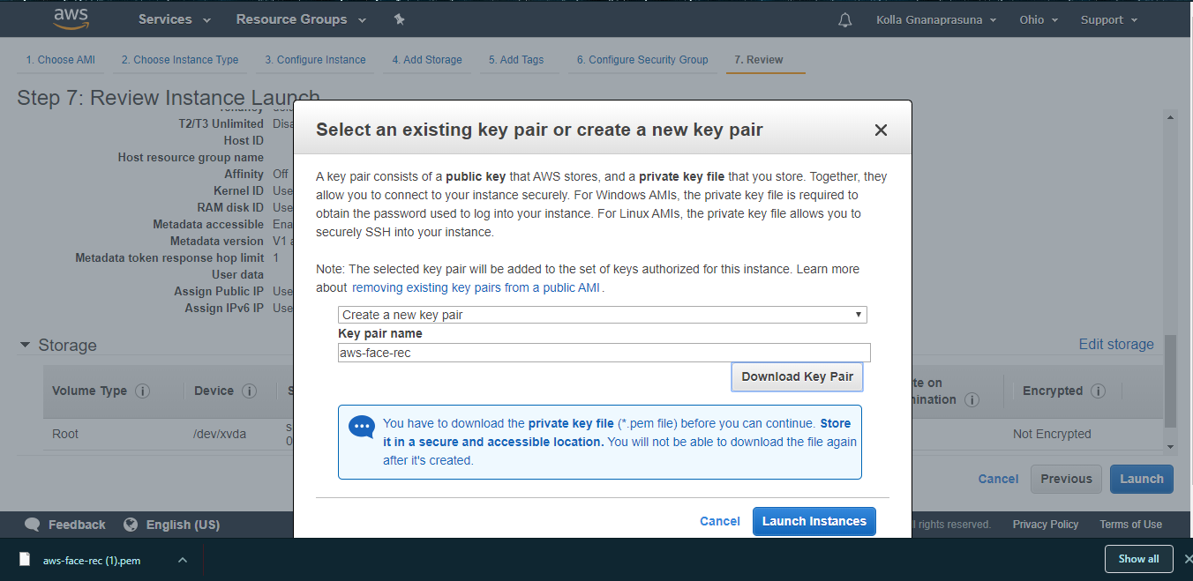

1. CONVERTING .PEM FILE TO .PPK FILE

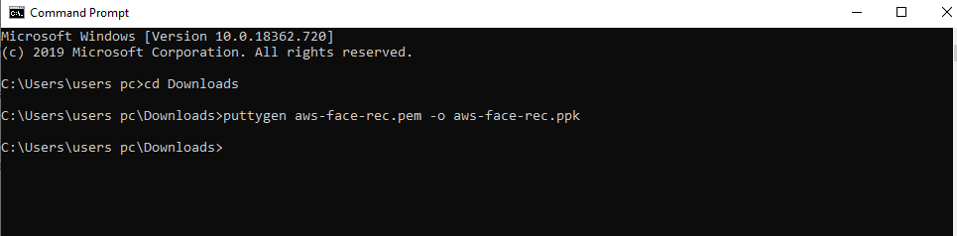

1. LOGIN TO EC2 BLACKSCREEN

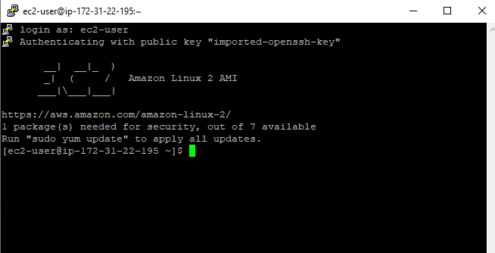

SCREENSHOTS NEEDED FOR S3

1. CREATING A BUCKET

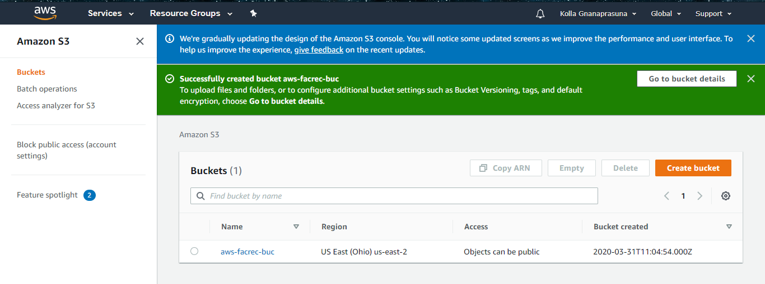

1. UPLOADING AN OBJECT

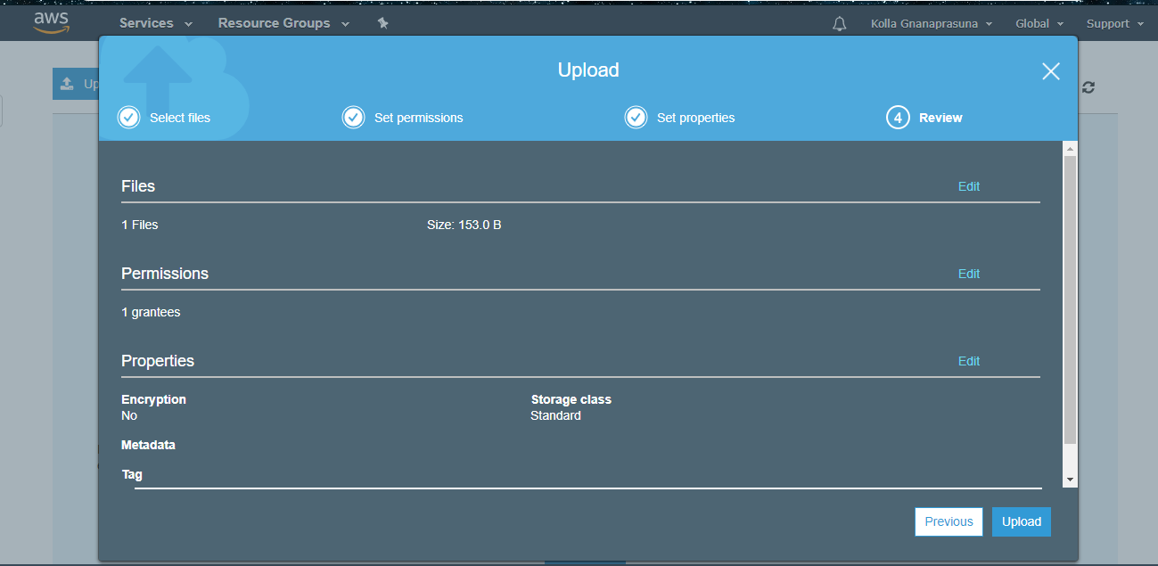

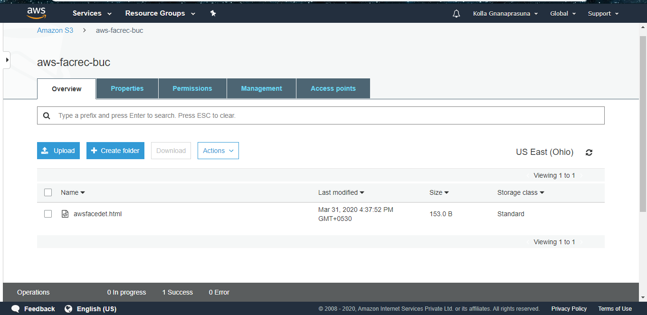

1. ENABLING STATIC WEBSITE

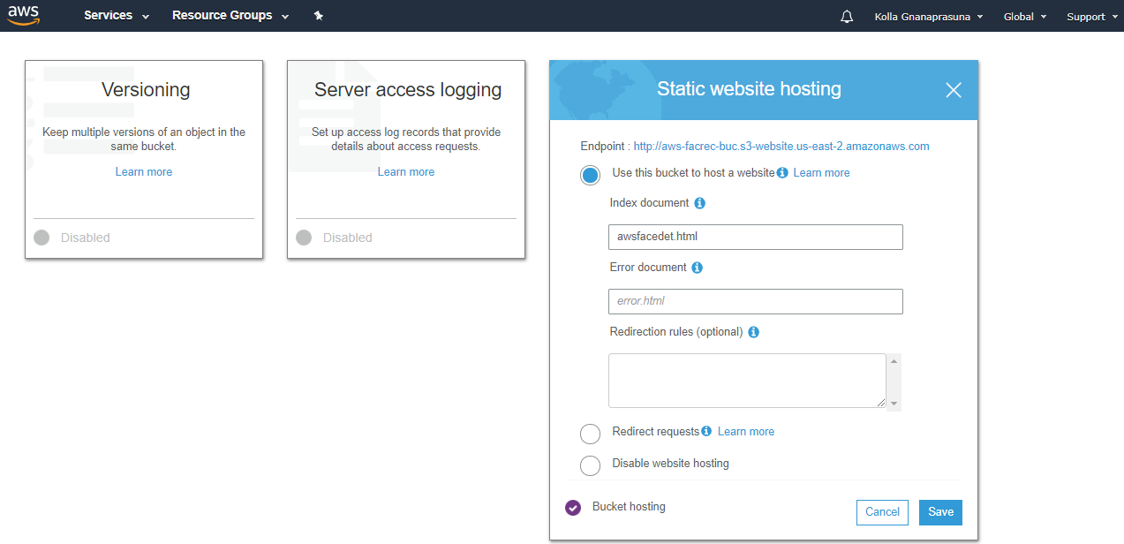

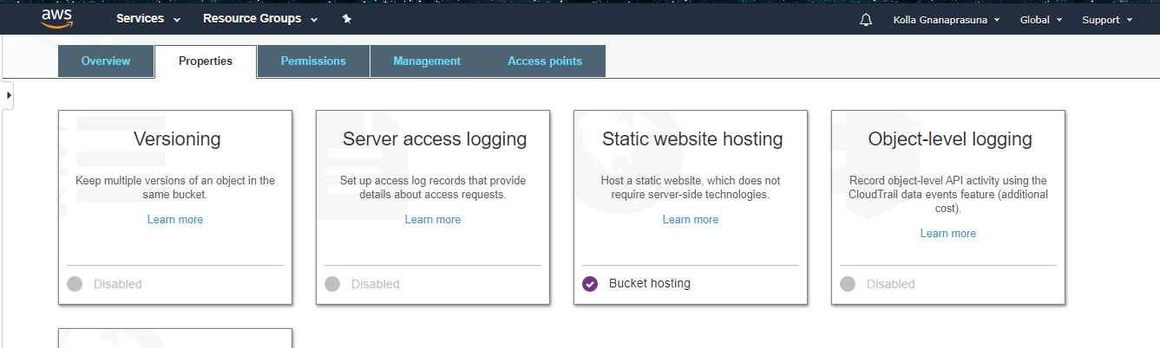

1. MAKING THE OBJECT PUBLIC

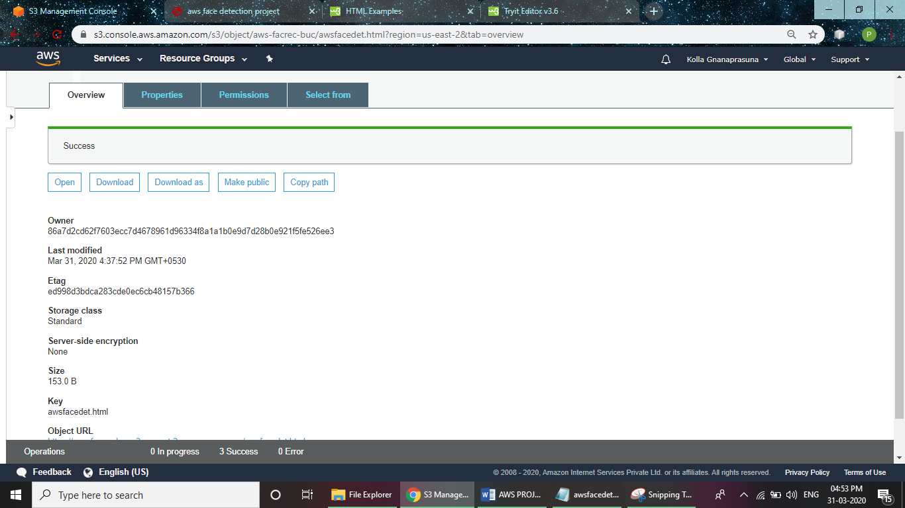

1. CHECKING THE S3 LINK ON THE BROWSER

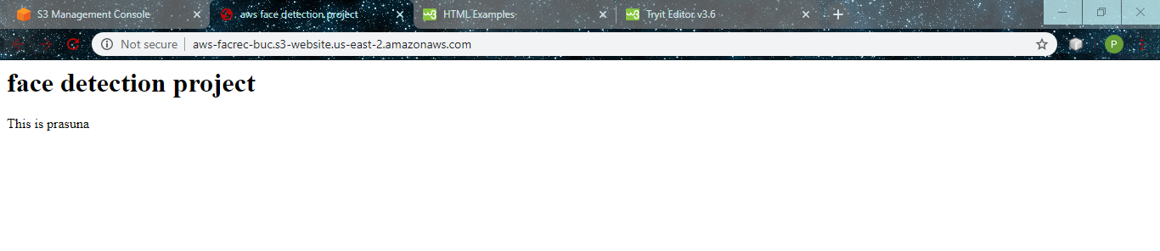

SCREENSHOTS NEEDED FOR EC2 AND S3

1. INSTALLING AWS – SDK

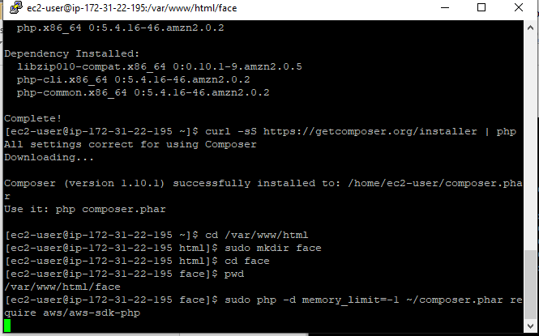

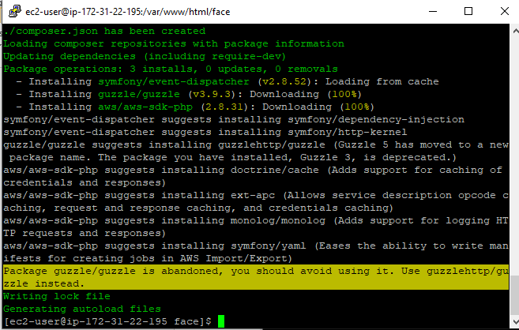

1. INSTALLING PHP

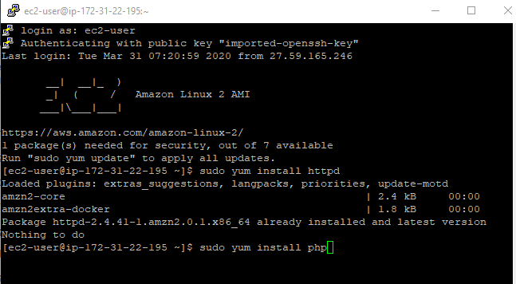

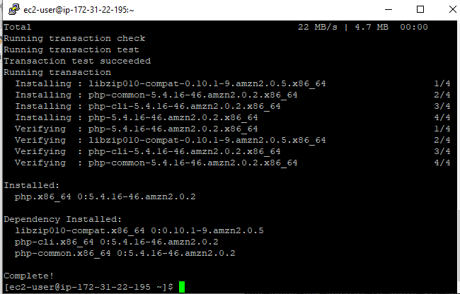

1. INDEX.PHP FILE CODE

<https://dm5migu4zj3pb.cloudfront.net/manuscripts/134000/134851/medium/JCI134851.f10.jpg>

1. <?php
2. /*
3. Install php - sudo yum install php
4. curl -sS https://getcomposer.org/installer | php
5. cd /var/www/html
6. sudo mkdir face
7. cd face
8. sudo php -d memory_limit=-1 ~/composer.phar require aws/aws-sdk-php
9. In case if you get memory error -
10. sudo /bin/dd if=/dev/zero of=/var/swap.1 bs=1M count=1024
11. sudo /sbin/mkswap /var/swap.1
12. sudo /sbin/swapon /var/swap.1
13. sudo wget https://i.pinimg.com/originals/b9/7e/a3/b97ea33b5842c7894b804923c6c05580.jpg
14. sudo mv b97ea33b5842c7894b804923c6c05580.jpg sample.jpg
15. Incase if you are getting any class NOT found error, follow these steps
16. sudo yum remove php*
17. sudo yum remove httpd*
18. sudo yum clean all
19. sudo yum upgrade -y
20. sudo amazon-linux-extras install php7.2
21. sudo yum install php-json php-xml php-cli php-mbstring
22. sudo yum install httpd
23. */
24. // error_reporting(0);
25. require_once(__DIR__ . '/vendor/autoload.php');
26. use Aws\S3\S3Client;
27. use Aws\Rekognition\RekognitionClient;
28. $bucket = 'aws-facrec-buc';
29. $keyname = 'sample.jpg';
30. $s3 = new S3Client([
31. 'region' => 'us-east-2',
32. 'version' => '2006-03-01',
33. 'signature' => 'v4'
34. ]);
35. try {
36. // Upload data.
37. $result = $s3->putObject([
38. 'Bucket' => $bucket,
39. 'Key' => $keyname,
40. 'SourceFile' => __DIR__. "/$keyname",
41. 'ACL' => 'public-read-write'
42. ]);
43. // Print the URL to the object.
44. $imageUrl = $result['ObjectURL'];
45. if($imageUrl) {
46. echo "Image upload done... Here is the URL: " . $imageUrl;
47. $rekognition = new RekognitionClient([
48. 'region' => 'us-east-2',
49. 'version' => 'latest',
50. ]);
51. $result = $rekognition->detectFaces([
52. 'Attributes' => ['DEFAULT'],
53. 'Image' => [
54. 'S3Object' => [
55. 'Bucket' => $bucket,
56. 'Name' => $keyname,
57. 'Key' => $keyname,
58. ],
59. ],
60. ]);
61. echo "Totally there are " . count($result["FaceDetails"]) . " faces";
62. }
63. } catch (Exception $e) {
64. echo $e->getMessage() . PHP_EOL;
65. }UPLOAD SUCCESS
66. UPLOAD SUCCESS SCREESHOT

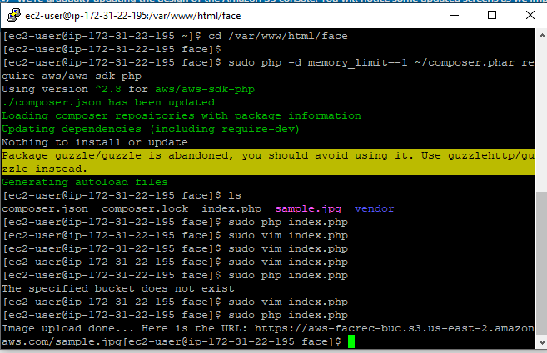

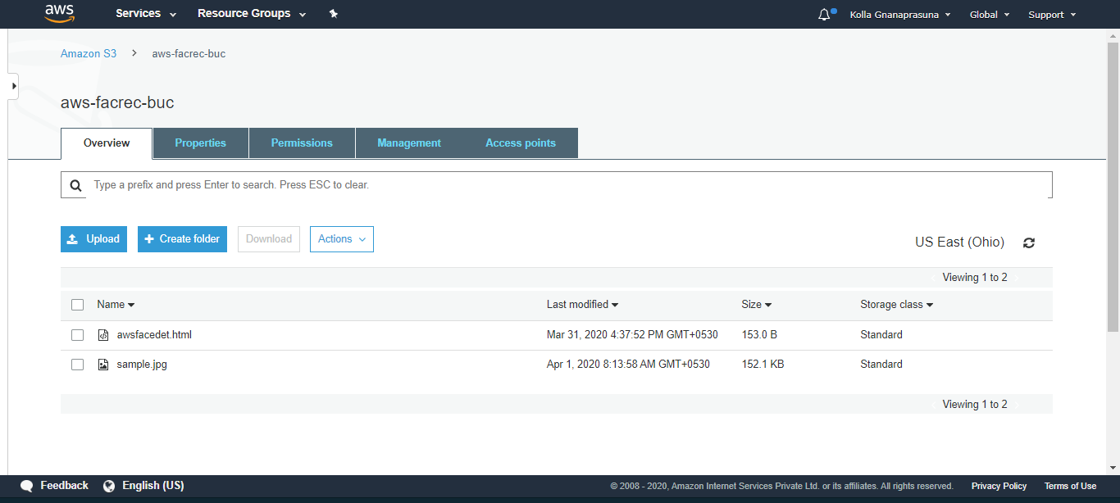

SCREENSHOTS NEEDED FOR REKOGNITION

1. FACE DETECT

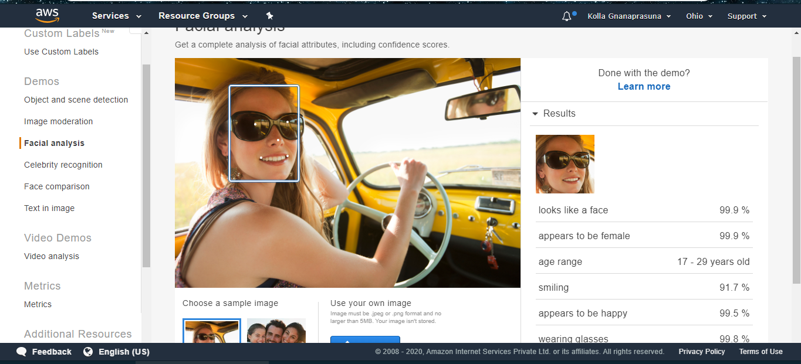

1. FACE COMPARE

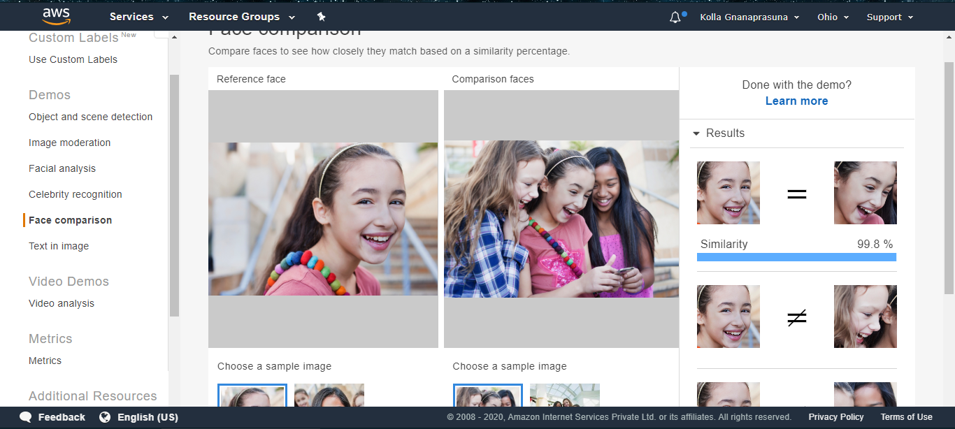

1. CELEBRITY RECOGNITION

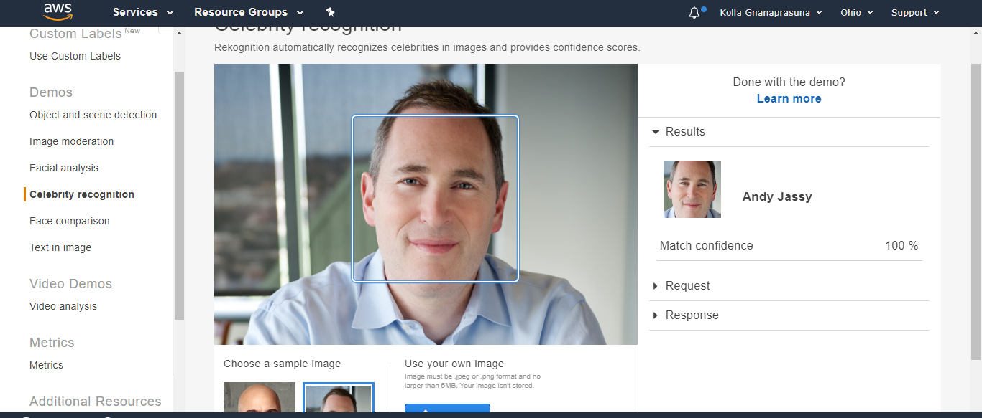

1. TEXT IN IMAGE

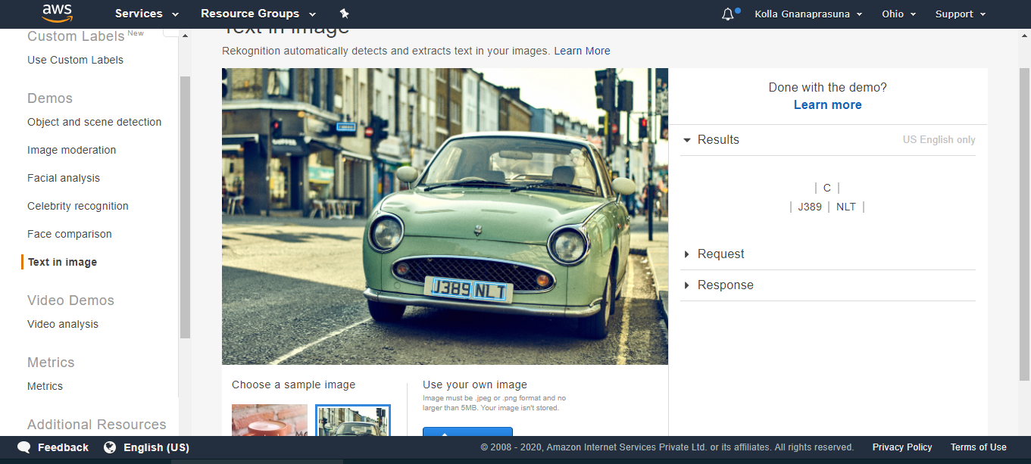

SCREENSHOTS NEEDED FOR EC2 AND REKOGNITION

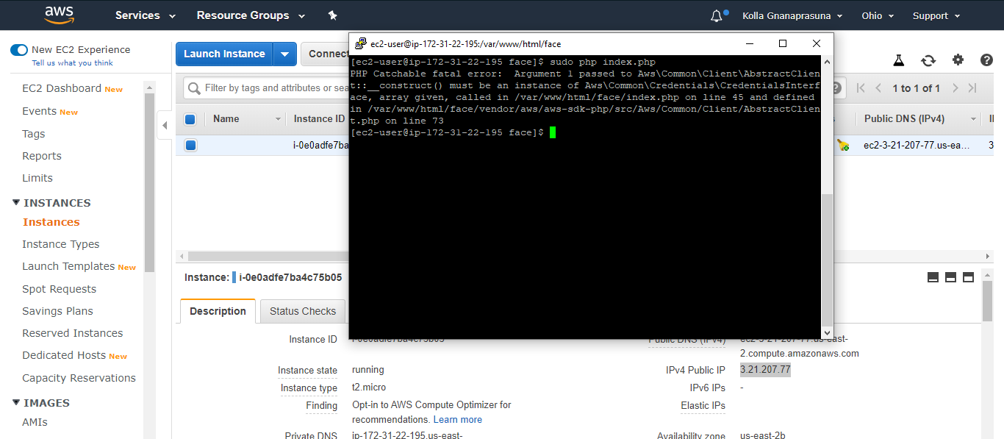

Sir, I got PHP catchable fatal error while running index.php file. I asked my query in the google form provided. But in the troubleshoot guide this error was not included. I don’t know how to resolve this error as I am new to AWS. Please help me on this.